*Metronome Logic Flow*

**About:**

The logic written in this document is based on the C# language, due to it being the most familiar language to all members of the group. This will need to be converted to C++ in order to work with the Arduino Yun, but the way in which the processes take place will be either similar or identical.

**The Problem:**

We have decided to use the Arduino Yun to record a beat (either by sound or vibration) and to output a LED signal that continuously repeats until a button on the Yun is pushed to end the program.

**Possible Solution:**

As suggested by members of the team, it is possible to tap the input mic with a rhythm for up to 6 seconds, multiply the recorded beats by ten to get the average beats per minute and then divide this number into sixty to find how much time there should be between each LED blip.

**Pseudo Coding Logic for Solution:**

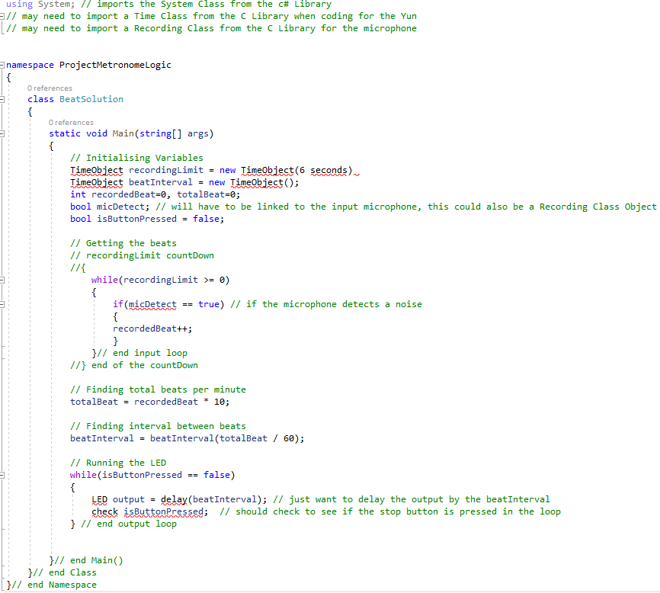

**Conversion from C# to C++ Steps:**

* Discover what class libraries need to be imported for this particular solution
* Discover correct syntax and keywords used by C++
* Create, Test, Repeat

**Hardwar Concerns:**

* Cables must be transferring data and power
* Keeping everything either analogue or digital, including pins and input/output devices
* Ensuring the Yun is configured correctly to the network

**Pseudo Logic for C++ Solution – May not be entirely accurate:**

